Cauliflower Information Pack
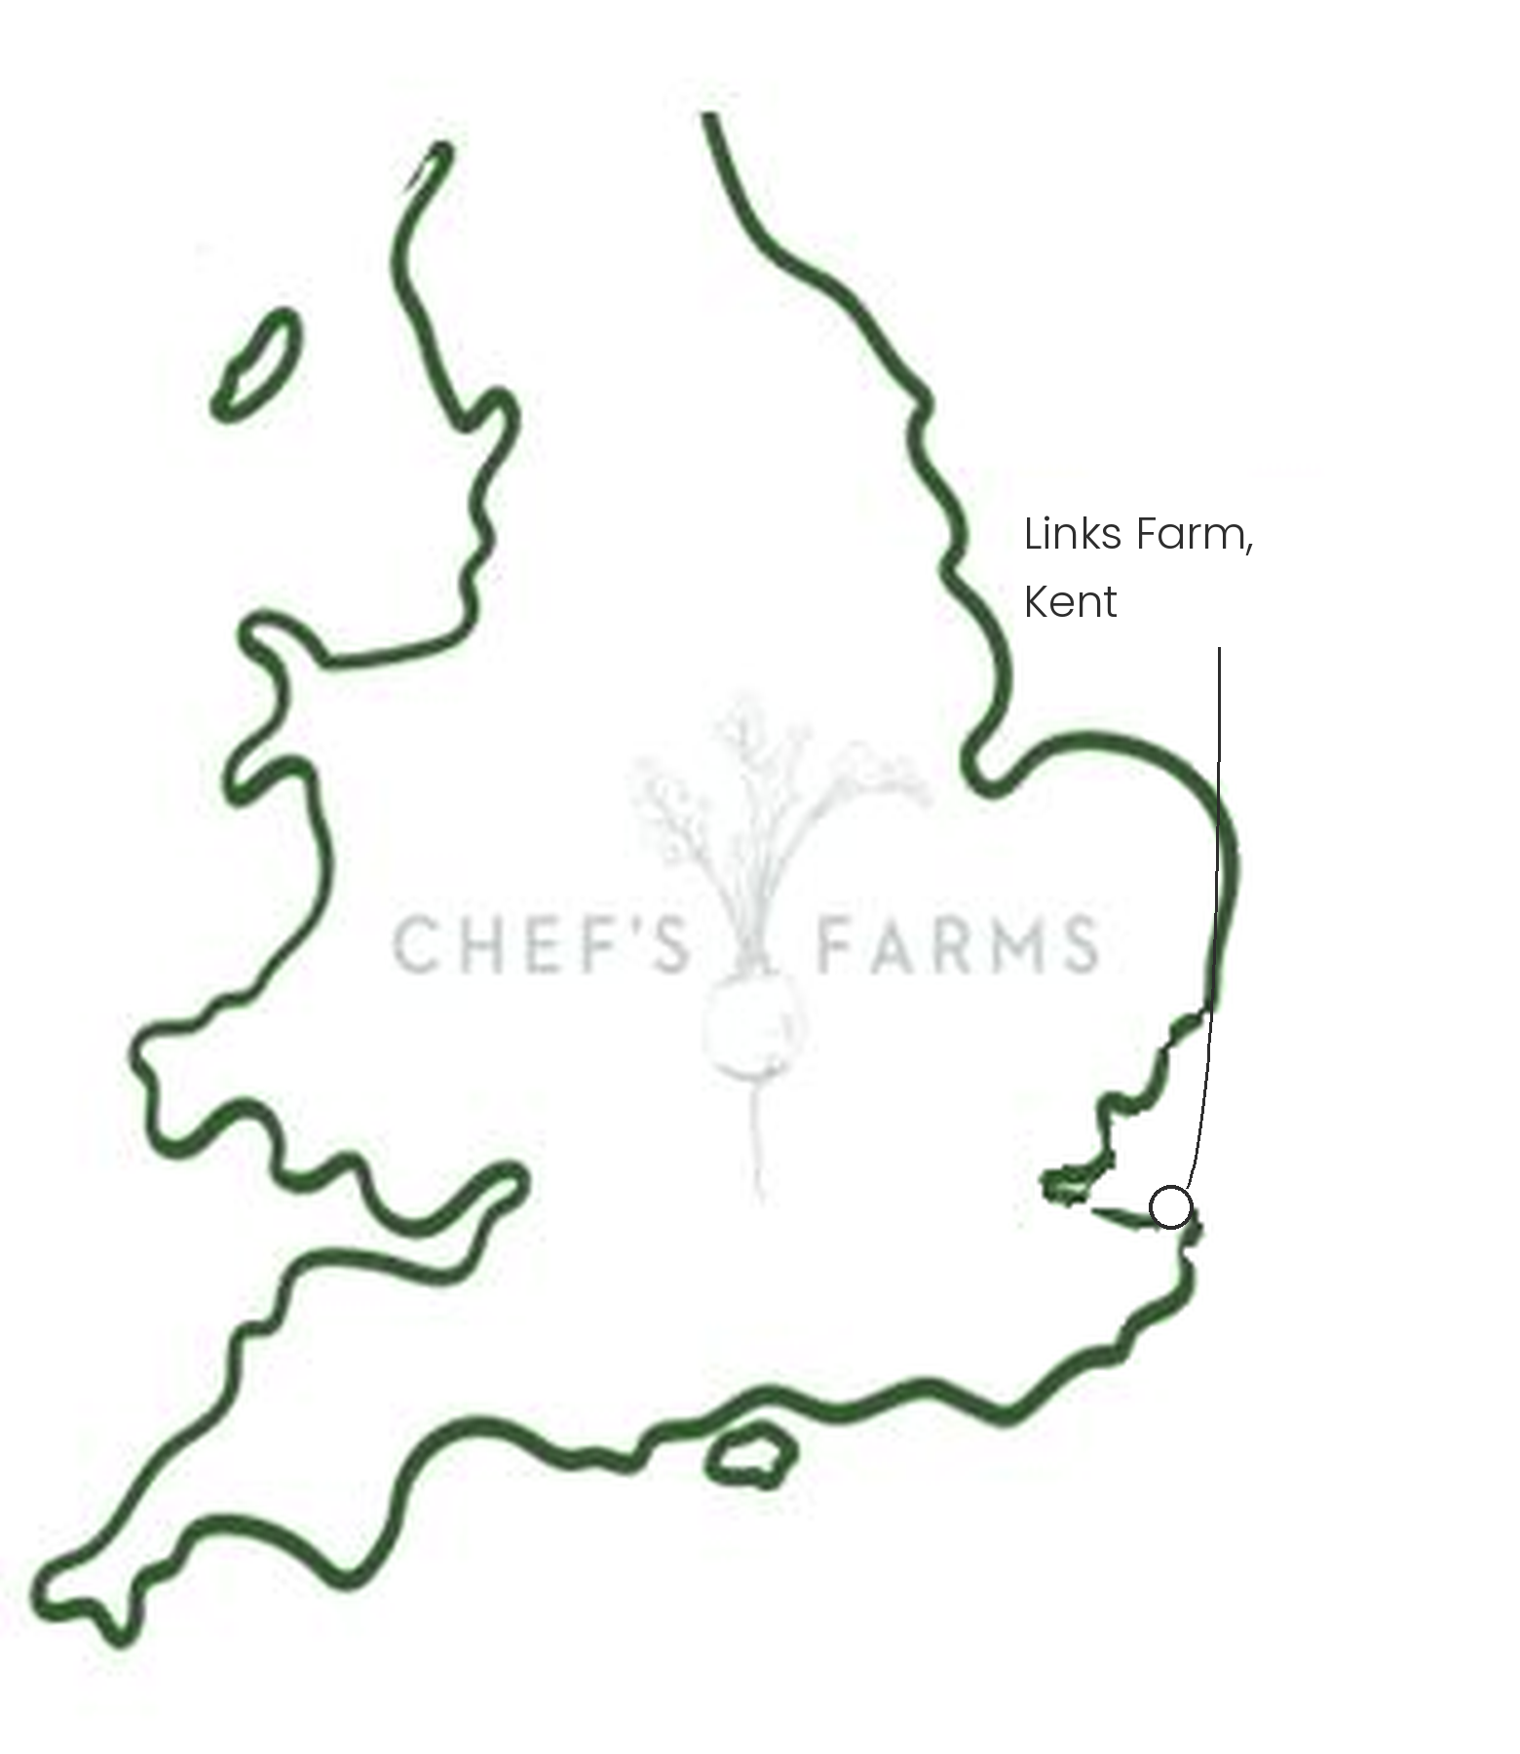
Introduction
Cauliflower is a brassica, the same family as cabbage and broccoli, and the head we eat is a tight mass of undeveloped flower buds. As it grows, the plant's leaves wrap around the head and shade it from the sun, which keeps it white.
Farm Information
Our cauliflower is grown by Charlie Bean, known to everyone as Beany, and the team at Links Farm in Kent.
Kent has a long history of growing cauliflower. Its mild, coastal climate means the crop can be grown across much of the year, with different varieties planted in succession so there is always a field coming ready. Alongside the classic white, Links Farm also grows purple cauliflower, which gets its colour from anthocyanins, the same pigment found in red cabbage and blueberries.
Like all brassicas, cauliflower is a target for cabbage white caterpillars, aphids and pigeons, and for soil-borne diseases such as clubroot. Moving the crop to fresh ground each season as part of a rotation stops these building up in the soil and keeps the land fertile.
The team also prepares cauliflower florets on the farm, saving kitchens time without the produce leaving Kent. We are proud to work with Beany and the team.
More
Cauliflower is available for much of the year, at its best from late summer through to spring. Roast it whole, cut it into thick steaks for the grill, or blitz it raw into a rice. Don't throw away the leaves either: they roast beautifully.
Nutritionally, cauliflower is low in calories and high in fibre, and a good source of vitamin C, vitamin K and folate.
Media
See shared album

